**Program No.06**

**Program title** To show simulation of led on/off using ldr sensor

**Aim**

Led should off when it is bright and on when it is dark

**Hardware Required**

Arduino board

LDR sensor

**Circuit**

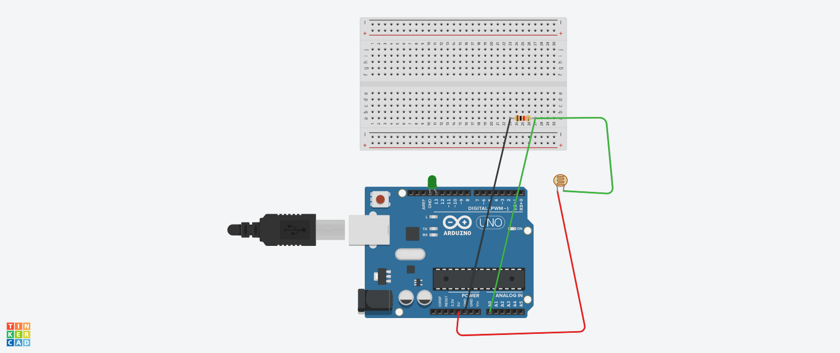

**Code**

int value;

void setup()

{

Serial.begin(9600);

pinMode(13, OUTPUT);

}

void loop()

{

int value=analogRead(0);

Serial.print("\nvalue=");

Serial.print(value);

if(value<=500){

digitalWrite(13,HIGH);

}

else

digitalWrite(13,LOW);

delay(1000);}

**Observation**

Led is on when surrounding is dark

And off when surrounding is bright